AI INTEGRATION & ARCHITECTURE DOCUMENTATIO
1. Service Category Classification Workflow
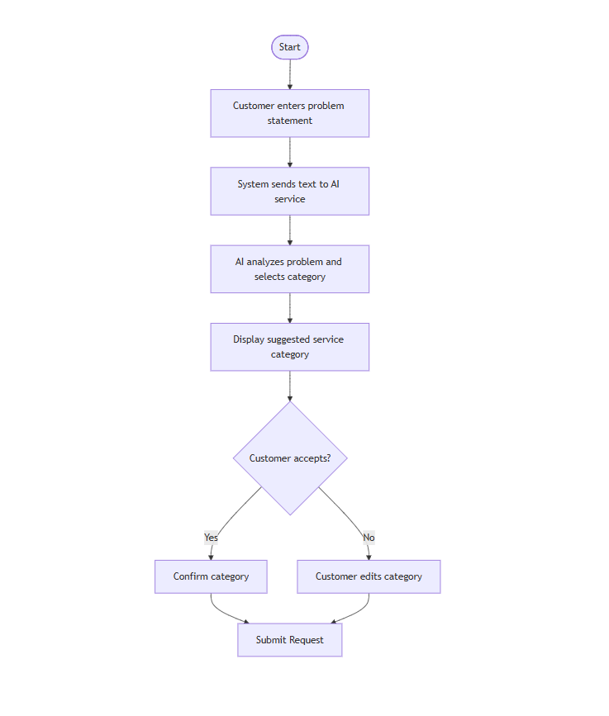This workflow governs how customer problem statements are dynamically analyzed and categorized using an AI model, with manual override safeguards to ensure data integrity before submissin.

2. Description Improvement Optimization Workflow
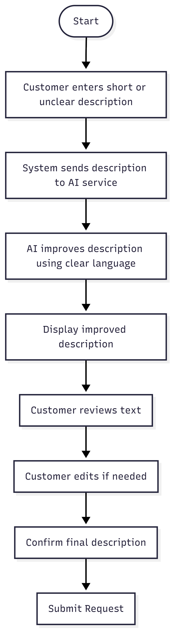This workflow outlines the text optimization subsystem designed to parse brief, incomplete, or ambiguous customer descriptions and automatically rewrite them for maximum clarity

